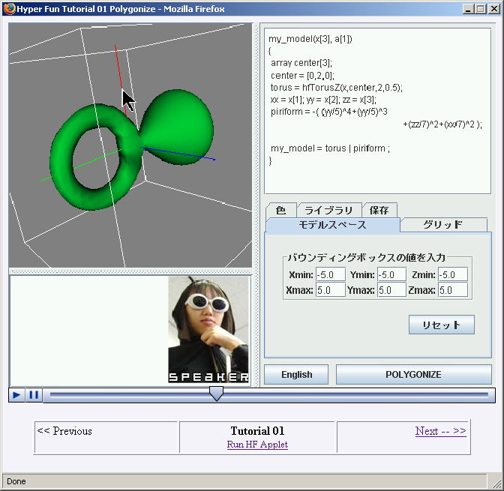
Figure 4. Web-based multimedia tutorial on the HyperFun applet

There are several types of on-line tutorials for HyperFun. One is a traditional set of HTML pages available in English and Japanese at the project Web site [HF]. This tutorial provides information for relatively passive learning the basics with some included exercises. Another type for more active learning is a Web-based multimedia tutorial for the HyperFun applet (available at http://www.cgpl.org/HF/). It is a sequence of nine Macromedia Flash animations showing various aspects of practical work with the applet accompanied by the audio explanation (currently in Japanese). The first six tutorials are about the use of the HyperFun Applet A snapshot of tutorial 01 is shown in Fig. 4. Note the possibilities to browse through the tutorial, to run the applet itself, to replay the animation, , and to observe an image of the currently speaking tutor, who changes from page to page. Tutorial 07 is a simple exercise. However a Cut&Paste link appears in tutorial 07 that spawns special window, that allows you copy different models from a number of more advanced exercises that are created from very simple HTML pages with out flash animation and therefore easily changed and customized.

