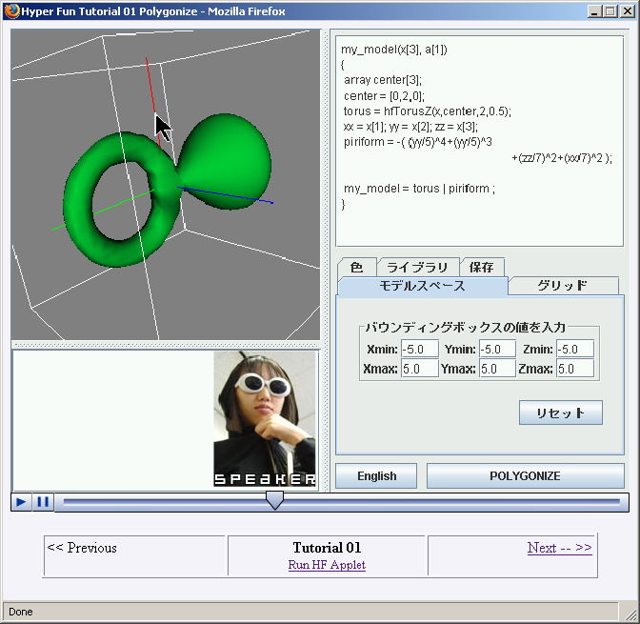
Figure 4. Web-based multimedia tutorial on the HyperFun applet

There are several types of on-line tutorials for HyperFun. One is a traditional set of HTML pages available in English and Japanese at the project Web site [HF]. This tutorial provides information for relatively passive learning the basics with some included exercises. Another type for more active learning is a Web-based multimedia tutorial for the HyperFun applet (available at http://www.cgpl.org/HF/). It is a sequence of Macromedia Flash animations showing various aspects of practical work with the applet accompanied by the audio explanation (currently in Japanese). A snapshot of this tutorial is shown in Fig. 4. Note the possibilities to browse through the tutorial, to run the applet itself, to replay the animation, to copy the current model from a special spawned window, and to observe an image of the currently speaking tutor, who changes from page to page.

