Reverse Construction of Cultural Heritage
C. Vilbrandt, G. Pasko, T. Vilbrandt, P.-A. Fayolle, M. Kazakov, V. Adzhiev, A. Pasko, T. Kunii
¹ University of Aizu ² IT Institute, Kanazawa Institute of Technology ³ Digital Media Professionals ⁴ Hosei University
Japan

Abstract
We give an overview of existing digital data structures, the mathematical representation of objects and the approaches to computer modeling of historical objects of cultural significance. Corresponding problems and solutions with long term archiving of digital data structures, constructive modeling, and a real time interactive display of the cultural heritage objects are discussed, various examples and applications are given.
Keywords:Cultural Heritage, Digital Preservation, Constructive Modeling, CSG, Function Representation, Fitting, Virtual Worlds

introduction
In this paper, we discuss the preservation of cultural heritage objects through the use of computer techniques using digital materials and processes. By digital preservation, we mean not only the digital reproduction of the surface shapes and colors of existing objects and the digital reconstructive modeling of objects that have already been lost, but also the digital representation and archiving of all of the physical properties of a cultural object or site, thereby allowing for the conservation of objects and accurate physical reconstruction of artifacts, which can be lost due to unexpected events. This is a particularly important issue in the realm of cultural heritage, since objects may be easily demolished, as the recent destruction of the Buddha images in Afghanistan has powerfully demonstrated. The preservation of cultural heritage has attracted considerable attention in computer graphics, geometric modeling, and virtual reality communities.
Digital Persistence and Preservation
First, we discuss the issues concerning the persistence of digital data structures and the need for long term digital preservation of cultural heritage objects. Preservation of cultural heritage objects with digital processes is not only theoretical possible but highly desirable for the reasons reviewed below. We raise with diligence two problems critical to the implementation of digital archiving technologies. We proceed to discuss applications of digital representation, modeling, and simulation technologies needed for digital preservation including real-time interactive access to cultural heritage objects for educational and artistic environments.
- Each digital reproduction is a perfect copy no matter how many digital reproductions are made. Digital reproduction can therefore in theory allow us to digitally archive data for thousands of years.
- The cost of basic digital material - electrons and photons - is very inexpensive. In very small amounts of space, large amounts of data can be stored, making it feasible to have many copies in many locations, thus assuring against loss due to unforeseen events.
- Much historical data and many cultural objects can not be accessed publicly (because of the cost and overhead of display, exotic locations, etc. [ref lauscaux caves]), whereas digital data can be publicly accessed on demand globally.
- Transparent learning through constant interaction with cultural objects in real time simulations, both locally and globally, is perhaps one of the most promising benefits from evolving digital modeling technologies. [ref to installations in museums and on line museums, ex. BBC]
- It has been argued by computer scientists, Hans Moravec and Ray Kurzweil, [ref] that the exponential evolutionary advancements of digital computational technologies will continue to provide more computational power and storage for less cost and space. This exponential advancement is limited in theory only by the size, speed and amount of available digital material and power.
Digital archiving offers many benefits and has great promise, however there are several significant problems and solutions, which are discussed below.
Problem: Currently, digital data structures are dependent on the hardware, OS, application and hundreds of copyrighted or patented application processes that involve a multitude of companies. Digital data dependencies are a great problem. Because of the exponential evolutionary advancements of digital computational technologies mentioned above, most hardware and software is updated every year. Over three years, the changes are significant, and after six or seven years, the original data can not be accessed.
Solution: Develop digital data structures that are robust and independent of: hardware , OS, application and hundreds of copyrighted or patented application processes.
Problem: The source code for most current digital processes are not open for public inspection. This means that not only are the processes not verifiable, but, without access to the source code of the processes, the data which is dependent on the processes will die. Processes and data are not able to be migrated into the future.
Solution: The source code for all of the processes must be open for public inspection, modification and testing, meeting the academic and scientific principles of rigorous proof and transparency of all operations. This assures the accuracy of the verification of the data, at the same time allowing for migration into the future. The way to assure that the source code can be open for public inspection is by the creation of a non-profit group and free source agreements. We submit that rigorous proof of complex digital manipulations that are entrusted with the long term digital preservation of cultural heritage is an essential key element to the development and implementation of the digital preservation system proposed in this paper.
Constructive Modeling and Engineering
We are proposing a paradigm yielding more than visible surface models for display. Our approach is based on constructive modeling that reflects the shapes, logical structure and the physical properties of materials and processes for the cultural object or site.
Constructive Solid Geometry (CSG) [Hof] and Function Representation (FRep) [PASS95] are practically applied as mathematical representations of the engineering of the structure at the same time providing for the independent robust data structures necessary for the digital archiving of cultural heritage objects and sites. Using CSG, one can begin by selecting simple shapes (primitives), specifying their parameters and positions in space, and then using them to construct more complex shapes by applying different set operations. FRep is a generalization of traditional implicit surfaces, CSG, and other shape models. It represents an object by a continuous function of three variables as F(x,y,z) ≥ 0. The function can be easily parameterized to support modeling of a parametric family. In FRep, an object is represented by a tree structure similar to one used in CSG, reflecting the logical structure of the object construction, where leaves are primitives and nodes are operations. Recently, a more general “constructive hypervolume” model has been introduced [PASS01], which allows for modeling multidimensional point sets with attributes, where an attribute is a mathematical model of an object property of an arbitrary nature (material, photometric, physical etc.). HyperFun [A99] is a minimalist programming language supporting all notions of FRep and constructive hypervolume modeling. Examples of independent CSG based reconstruction of historical temples and FRep based modeling of traditional Japanese lacquer ware and modern sculptures are given.
We also recognize the cost problems associated with large amounts of labor in the reverse construction (reverse engineering through constructive modeling) of cultural heritage objects. Accordingly, we are seeking to reduce the amount of time and skill to make constructive engineering details including volume modeling of mixed materials. Therefore, we examine the application of fitting of a parameterized FRep model from a cloud of data points as a step towards automation.

CSG Modeling and virtual heritage: Japanese temples
2.1 Constructive modeling of historical buildings
Considering the authors' experience in lost work and data due to obsolescence of software and hardware, the authors specified CSG representation as the most promising persistent data structure for modeling historical architecture of the Aizu History Project. [15] All parts of two historical buildings, the Golden Hall at Enichiji and Sazaedô featured in this paper, were created whenever possible with only CSG based entities. However, because CSG is limited in its range of shape representation and the overall size of each model was extremely large, the thatch roof of the Golden Hall and the double helix ramp inside Sazaedô had to be represented by a polygonal mesh. We used AutoCAD rel 12 software with Advance Modeling Extensions (AME). AME is the implementation of CSG with the CSG tree history. Furthermore AutoCAD rel 12 using AutoLISP allows for direct access to the CSG tree history and the creation of third party programs such as the creation of export programs for CSG data. The authors are creating a free source code HyperFun modeling module for AutoCAD rel 12. We have found many errors in the AutoCAD AME implementation of CSG. However, we only have access to the AutoCAD CSG data tree and not the source code for the AME CSG module.
The original modeling of Enichiji and Sazaedô began eight years ago on 386 and 486 Intel class machines using AME CSG. The computational demands using CSG representation were so high that sections of a single model had to be developed in many separate files on as many as four different machines. However, the authors knew that the exponential computational evolution would continue and, in a few years, we would be able to use one machine. There were significant problems in data creation and manipulation of sections of the buildings across separate files on different computers as the coordination was all manually done. When combining the files into one file, it is needless to say that this data overwhelmed even the fastest single system at that time. Now, the entire model of Sazaedô with polygon reduction can be handled easily in real time on current animation and rendering systems. The efforts the authors experienced using CSG in commercial products on individual PCs with the goal of creating digital archival data seems wasted. There is some doubt that even this CSG constructed data will live through the next several decades because of the proprietary nature of the AutoCAD commercial software. We had anticipated that AutoCAD Rel 12 made for Windows 3.1 would stop working on newer MS operating systems like Windows 2000 or XP and that we would have to use older systems to do the programming necessary to migrate the data onto new platforms, such as HyperFun and Linux. However AutoCAD rel 12 was well programmed, and AutoCAD rel 12 AME continues to work on newer systems.
However, we have found errors in AME, such as the order of subtraction and union operations are not interchangeable in some cases and extrusion with taper is not accurate. Therefore, the quality of the AME CSG modeling database is in question. It will take more effort to extract the CSG data structure embedded in AME than it would to model the buildings again, but this is a part of our planned research. Since we started, the HyperFun modeling language based on function representation has been developed. The next step in our digital preservation research is the creation of a "CAD" style third party program for HyperFun in AutoCAD rel 12. This is the first step in developing a separate Synthetic CAD modeling system. We need to mention and give credit to the great programmers that created AutoCAD and note that, if it were not for the many forms of open data access within the AutoCAD program allowing the use of AutoLISP for modification of its user interface and data directly, we could not have done the work at all. The development of translation tables from four different measurement systems used in the historical documentation for the temple buildings and the development of a complete 3D modeling interface in AutoLISP by the authors made the modeling work possible. After twenty years of extended use of AutoCAD software, even with its stiff drafting paper style interface making it very difficult to move the user view point, it will be missed when it no longer runs on future platforms.
The benefits of using three-dimensional graphics techniques in constructing models are obvious. First of all, models can be manipulated to provide multiple viewpoints. Rotating a model can provide a better understanding of the physical relationships of the components of the actual structure, as well as the construction techniques involved. Moreover, three-dimensional models can replicate the actual construction of the building itself, including features normally hidden to the eye, such as interior bracketing, and the model can be deconstructed to reveal such hidden features. Images of our work below on the two Buddhist temple buildings in the Aizu region of Japan illustrates these benefits.
2.2 Golden Hall at Enichiji
The first structure that we modeled using the AutoCAD AME CSG system was the Golden Hall at Enichiji, a temple located at the foot of Mt. Bandai. Although Enichiji was the religious center of the region throughout much of the Heian period (794-1185), no buildings or images from that period are extant today. In order to produce a model of the Heian Golden Hall, the structure that housed the temple's most important Buddha-images, the authors relied on data introduced in archaeological site reports. [16]
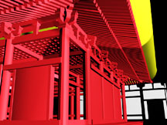
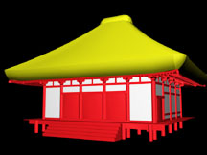
Figure ??: Structural view Figure ??: Normal view

The construction of the Golden Hall model was a difficult task. At present the only solid information is the existence of seven foundation stones for pillars, demarking the north and part of the east walls. A base of piled stones also stretches along the north and east walls, and remains of a retaining wall abut the (surmised) southwest corner. This information has led archaeologists at the site to conclude that the building measured five bays from east to west and four or five from north to south. We have constructed the Golden Hall model as a five by four building (Figs. ?? and ??).
In addition to archaeological data, the model was based on standard temple-building practices of the eighth and ninth centuries.[17] We also took into consideration the snowy climate of the Aizu region, which dictated a steeper roof slope than is common in other areas of Japan. In addition, we consulted Yamagishi Seiji, a master miya daiku (shrine carpenter) and the scion of an 800-year carpentry tradition in this region.

2.3 Sazaedô Pagoda
Recently declared a National Important Cultural Property, Sazaedô, a pagoda built in 1796 in Aizu-Wakamatsu, is noted for its unique architectural feature, a double-helical interior walkway that takes visitors from the front entrance to the top of the structure, then over and down to the back entrance. The double helical walkway is part of an interior tower (Fig. ??). (For more details on the Sazaedô construction, including black and white reproductions of these figures and some others, see Vilbrandt, Goodwin, and Goodwin, 1999.[18] The drawings in the figures below were adapted from engineering blueprints done in 1965 by Kobayashi Bunji.)
The 3D CAD model can be used to display such components separately, so that the construction may be seen and understood. Even an actual visit to the site does not enable such views. For example, the entrance and its canopy are structures which can be better understood from the model than from a photograph or even from a visit to the actual site, since they are complex objects and access and sightlines are restricted. [ref]


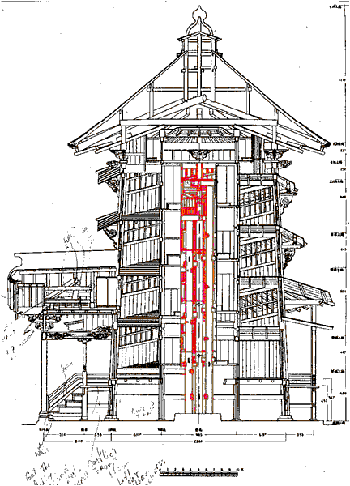
Figure ??: (from left to right) Interior tower in wire frame, interior tower colorized showing alcoves, drawing showing the location of the interior tower.
By using measurements from an engineering drawing (Fig. ??) of the roof shown from below, and supplementing them with measurements taken on site, a 3D CAD model was constructed, and is displayed in the wire frame view and the rendered views (Fig. ??).
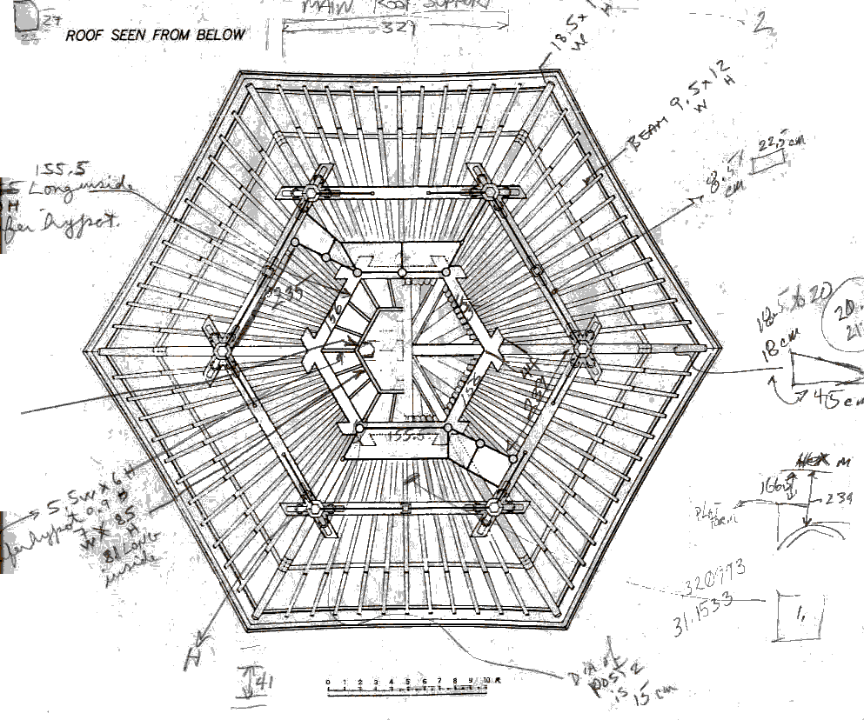
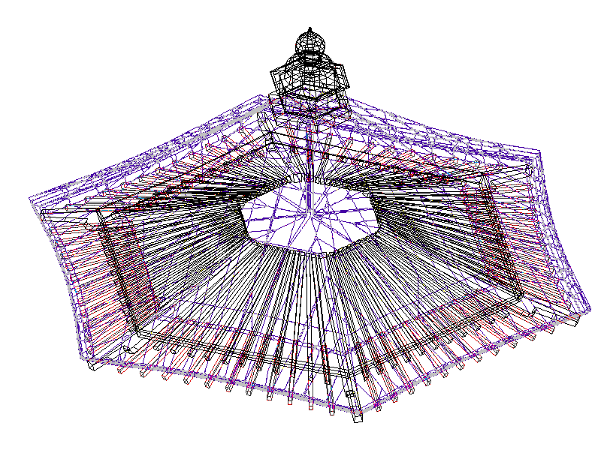
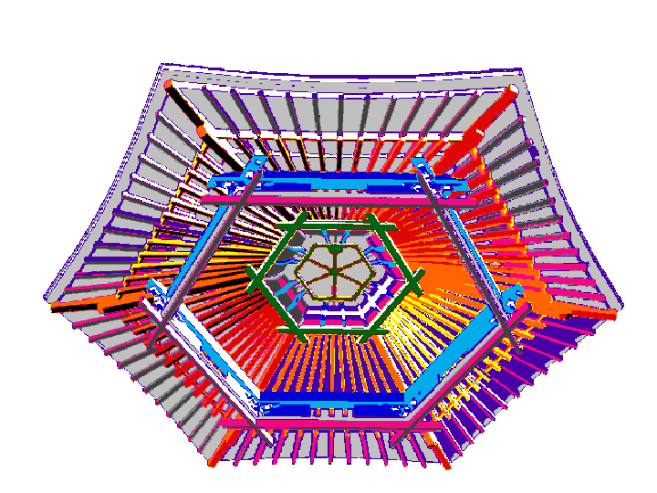
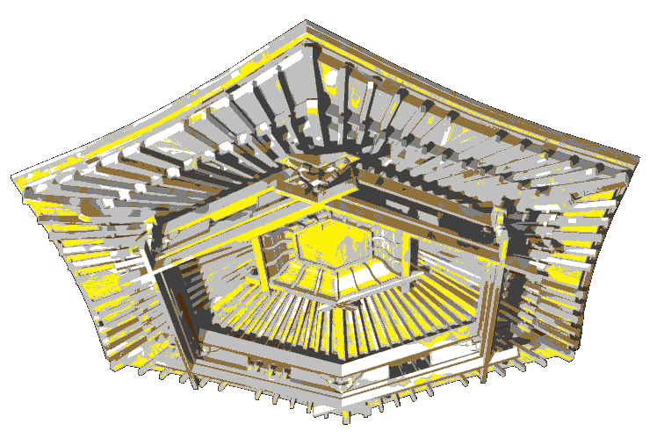
Figure ??: Roof Views

It is possible to select only one section from the single CAD model of the entire structure, and display it from multiple viewpoints and with various levels of detail. Because of the constructive approach, any part, such as the helical structure, may be rendered without displaying the other components, and an external shell may be fully rendered (Fig. ??).
The models illustrated are virtual constructions using virtual lumber cutting, positioning and joining according to the specifications of the miya daiku based on empirical knowledge of the past. By virtual lumber cutting, positioning and joining, we mean that we create each piece of the temple from virtual parts that represent the shape of each piece of lumber in the same order that would have been used by the miya daiku. The virtual lumber cutting, positioning and joining empirically show the value of digital preservation of cultural heritage using constructive modeling. The 3D model has recently been used to produce high quality renderings of the interior of Sazaedô, as would be seen by a person walking through the structure, [19] and to produce QuickTime and AVI movies of the journey through the temple (see http://ggpl.org/saza2001). We plan to enhance the current model by including 3D reproductions of the images formerly enshrined in the building. We also intend to develop VR facilities to allow the examination of these images independently (see section on real time experience), and to allow the viewing of parts of the structure that cannot be accessed in the actual building.
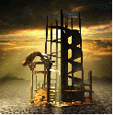
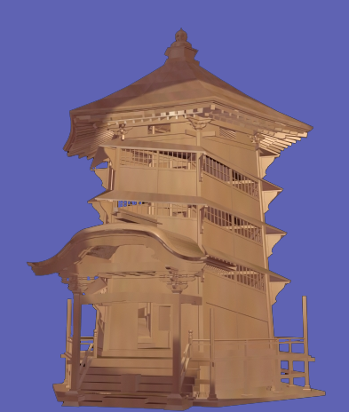
Figure ??: Rendered model with helical structure and fully rendered exterior shell.

2.4 Virtual Surfaces to Synthetic Objects
The miya daiku uses parts of the tree or piece of timber in a specific place or way. Therefore, the timber is milled in a specific manner, and the parts of each piece of timber are noted and used together to create what the miya daiku understands as a "living" harmonious structure. A simple example of this specific use of timber by the miya daiku is the fabrication of the main columns of the temple, which are cut from trees growing on four sides of a mountain. The orientation of these trees to the earth and to each other on the mountain is maintained as the columns in the temple structure. With the use of HyperFun representation, we can reach beyond the virtual surfaces of a wooden object. In the future, with records of weather and growth rings of trees, we can synthetically grow a tree using volume modeling and fabricate synthetic pieces of timber, using the same type of traditional miya daiku procedures, to create a synthetic representation of such ancient temple structures. Synthetic simulations of the miya daiku procedures in constructing traditional temples would not only archive the historical objects themselves but allow us a deeper understanding of the miya daiku craft.

parameterized FRep modeling: lacquer ware

FRep modeling of Japanese lacquer ware
We illustrate here the preservation of traditional crafts such as lacquer ware (Japanese shikki) manufacturing using FRep modeling. The “Virtual Shikki” project [PPVI01] includes the following activities:
- Reconstruction of shapes and making parametric families of models of representative shikki items. A parametric family of models allows us to generate samples of a specific model with different sizes, width/height ratios, and so on, without repeating the entire modeling process, and to apply parameters fitting from the real objects measurementrs and scanning
- Digitizing textures. There are technical problems of scanning colored textures from the surface of existing lacquer ware items.
- Producing 3D virtual objects and presenting them on the Web. [VS] using Virtual Reality Modeling Language (VRML) (see Fig. X).
The process of modeling shikki shapes included the selection of representative items, the measurement of the coordinates of control points, the introduction of the basic logical structure of the model (primitives and operations), the description of the parameterized constructive model using the HyperFun language, visualization, and selection or fitting parameters of the model. Development of some additional specific operations, for example, bounded blending [PPIK02] were required for adequate modeling of shikki shapes.
Figure X: Front and top views of a Virtual Shikki object..

Fitting as an FRep modeling tool
Modeling specific shapes based on real world objects require a large amount of routine labor in measuring control points and fitting model parameters. Semi-automatic methods based on using 3D scanned points as control points and non-linear optimization for automatic fitting of parameters can be used to make the work of the modeler easier.
Some of the most useful methods for solving problem of nonlinear optimization for fitting parameterized models in the least square sense are presented and then applied to the concrete example of the sake pot previously presented in the virtual shikki case of study.

Data modeling and nonlinear least square approach
Given a parameterized Frep model, describing the global shape of the object, and a set of 3D points on or near the surface of this object, the task is to recover the best set of parameters so that the parameterized Frep model closely fits the data points. The 3D points, typically obtained by a scanner, will serve as control points for the final shape of the object. The vector of parameters from the Frep model control the final shape of the solid and the best fitted parameters should give the closest possible model according to the information provided by the control points.
For computing how close a given point is to the surface of the solid with the current vector of parameters, a fitness function is needed. The Frep model itself can serve for defining an algebraic distance, because of the natural distance property of Frep functions. The least square error, or error of fit, for the model is the sum of the square of the defining function at all points.
Taking the square instead of the absolute value of the residual, allow to consider the least square error function as a continuous, and differentiable function. Techniques of minimization of function can be therefore used with the least square error function. Unfortunately, FRep models are nonlinear, and so is the least square error. Nonlinear optimization methods need to be applied, local and global nonlinear minimization techniques are considered.

Local methods for nonlinear minimization of function
The most traditional methods for solving problems of nonlinear least square fitting are Levenberg Marquardt or Newton type [DGW81, Mor78, PFTV92]. Such methods rely on a local quadratic approximation of the function being minimized; this quadratic approximation is obtained by a Taylor serie expansion of the function in the vicinity of the current vector of parameters.
The algorithms for Levenberg Marquardt or Newton methods search iteratively for a privileged direction to go in the parameter space and a step to move in that direction, based on the information given by the gradient and the Hessian matrix of the function.
Such classical methods can only guarantee a convergence to a local minimum. In that sense, they are considered as local methods only. For some parameter spaces with complex topology like for example where multiple local minima exist, such methods are likely to be trapped into a local minimum and to stop there. Good initial parameters are very important, because they will determine to which minimum the algorithm may converge. Usually, if the parameters are not in the neighborhood of the global minimum, it is unlikely to converge to it, and the method will reach instead a local minimum.
It is possible with some further analysis of the model to have some additional informations for getting a better estimation of the starting parameters. It may be also possible to restart the algorithms with a different starting point to see if it comes back to the same minimum.

Global methods to avoid local minimum
In contrary to local methods for nonlinear minimization, global methods are intended to find the best possible solution to an optimization problem. The starting point in parameter space should become less problematic.
Simulated annealing is one of these methods, that received lots of attention for solving problems of optimization, both in discrete and continuous spaces [GFR94, KGV83, MRR+53].
When trying to minimize a function usually only downhill steps are accepted, but in simulated annealing uphill steps can be accepted with a probability, initially close to 1 and decreasing to 0 with the temperature of the system.
The method of simulated annealing has been inspired by the behavior of some thermodynamical processes. In liquids with high temperature, the molecules move freely with respect to one another. When the liquid is cooled down, the mobility of the molecules decreases, and finally they stop. If the cooling process is not too fast, then the system will finish in a state of minimum energy. The above observations have been applied by Metropolis to numerical computation.
Methods based on simulated annealing may be a good alternative to classical direct methods in global optimum search among many local optima, but they are facing some major problem of efficiency: the objective function needs to be sampled a huge number of times before reaching convergence.
Because of that, simulated annealing seems to be a less interesting option for nonlinear fitting of FRep. A suitable solution would be to combine it with a more direct method, and to switch between the methods once the neighborhood of the global minimum has been reached; we explore this potential solution in the next section.

Local methods for nonlinear minimization of function
In order to overcome problems of both methods presented in the previous sections, a two stage algorithm is proposed. At the beginning a global method like simulated annealing is used to identify the vicinity of the global minimum, then a local, faster method, is applied, to extract the parameters that closely fits to the 3D point set.
Switching to a local method occur when the error is below some threshold or when the parameterized model looks close enough to the data set.
The result of this two stage process is a method faster than a pure global method, and that can also avoid the local minimum.

Experiments
The two stage process has been applied to the fitting of the sake pot from the Virtual Shikki case study. The initial set of control points is made by 27048 3D points on or near the surface of the object (see figure 1)
Figure 1: Point data set used for reverse construction (black) and an intermediate shape during the fitting process (green).

The parameterized Frep has four free parameters meaning the position of the object in the space, the radius of the main body, and the last one controlling the shape of the handle.
It took 347 seconds on a Pentium IV processor laptop for the two stage algorithm to the global minimum. Most of the time is spent in the global minimization procedure (341 seconds). The final reconstructed model as a mean error of 0.03.
Figure 2: Evolution of the shape of the sake pot during the fitting process.

The figure 2 gives intermediate steps for the evolution of the shape during the fitting process.

Making History realtime
In our research, we are exploring the use of optimized real time game engines as a method of viewing 3D content. These applications provide built in logic to handle basic world properties like gravity and collision detection. In addition, 3D games provide highly intuitive and efficient user interfaces, advanced network code for multi-user distributed environments, and an open coding environment allowing unlimited customization.

  - Realtime versus rendertime
In real time simulation using gaming methods, a user can interact with the program, as well as with other users, in an immersive and entertaining environment. However, the restrictions imposed on a real time environment are significant. Even at relatively slow frame rate of ten frames per second (barely adequate for games), all computation for each frame must be finished within 100 milliseconds. Even on the most powerful gaming systems, this hardly allows for the level of complexity we might want in a historical simulation model. Such desired levels can be precalculated or calculated on demand by computational grids and presented as visualizations in various formats inside the real time game environment, transparent to the user.
Currently, at the University of Aizu Computer Arts Lab, we have modeleld such a system using Quake [ref] as the front end client and Povray as the backend server. Our test case is a model of the Enichiji temple. In order to provide an immersive environment, we have created a model of this temple which runs in Quake, and allows the user to climb the stairs, inspect the internal architecture, and move under, over, through or around the temple in full real time. At any location in the Quake environment, the user may choose a detailed Povray rendered visualization (Fig. ??).
Put 2 images from Corel Draw file here
Figure ??: Inside the Enichiji temple model: on the left is a view of the real time Quake model in low detail; on the right is a detailed raytracing delivered to the client in seconds after a view is selected.
Currently, we are working to incorporate the HyperFun geometric modeling language into the Quake game engine and web technologies.

FRep animation and interactive experience: augmented sculpture
In the Augmented Sculpture project [ACP03] we investigate an original approach to computer-based sculpting. Starting with a physical sculpture, we produce its computer model and we manipulate this model to produce new shapes that can eventually be manufactured to produce a new physical sculpture. We call this approach "augmented sculpting" as it extends the existence of physical artefacts to a virtual computer-world and then closes the loop bringing new computer models into physical existence. There is Augmented Sculpture Web Page:
http://cis.k.hosei.ac.jp/~F-rep/App/ASP/FASP.html
Modern abstract sculpture is very much concerned with the exploration of novel non-trivial shapes and we believe that the computer technology being presented here can assist artists in their creative quest. Functional representation methods actually employ constructivist techniques that allow the emulation of physical or virtual “building blocks” in the form of geometric primitive shapes that can be combined in complex spatial relationships. A computer-based means of sculptural representation along with a specific environment where the sculptural shapes are set can lead to the production of artefacts with a new aesthetic. Consequently, viewers experiencing these shapes within a virtual space can also benefit from this technology.

Real Sculptures and Their Models
Our case study is based on real (physical) sculptures created by Moscow artist Igor Seleznev (www.russian-art.org). Figure 1 shows photos of two “real” bronze statuettes “Gymnast” and “Naked”. First, it was necessary to construct the geometric models of the sculptures which have quite complex shapes with subtle features.
Figure 1: Physical Sculptures
“Gymnast” was modelled in HyperFun language using basic geometric primitives defined by equations as well as by the following set of FRep functions: non-linear deformations (hfBending3D), affine transformations (hfShift3D, hfScale3D, hfRotate3D) and blending (hfBlendInt, hfBlendUni). “Naked” was modelled using the following FRep functions: ellipsoids (hfEllipsoid), convolution surfaces (hfConvPoint, hfConvLine), affine transformations (hfShift3D, hfScale3D, hfRotate3D), blending intersection and union operations (hfBlendInt, hfBlendUni). Note, that so-called convolution surfaces [MS98] which are a class of implicit surfaces allowing for modeling complex non-regular forms were especially helpful.
Model building and debugging was carried out using the “HyperFun for Windows” toolkit, and the final ray-traced renderings (shown in Figure 2) were generated using the “HyperFun for POVRay” toolkit.

Animation of Sculptures
Once the model of a physical sculpture is created, one of the most natural things that the artist may wish to do would be to alter the material that could have been used to create the physical sculpture and to explore the visual appeal of such alternatives. To achieve this, within the functional framework, we may employ a texturing method based on the Hypervolume modelling techniques [PASS01]. In [SPAS01] we have applied such a technique to the model of the "Naked" sculpture.
Figure 2: Images of models
What would also be quite interesting for an artist to do and, obviously, impossible without computer technology, would be to have the ability to animate a sculpture which being initially still, has internal (although hidden) dynamics and therefore a natural propensity to move. There is a traditional division in computer animation made between the modelling and the animation processes that leads to limitations of the forms that can be animated. The advantage of the FRep [PASS95] is that one can work with both the shape and its animation simultaneously. So, time-dependent shapes can be modelled directly as four-dimensional (4D) objects with the subsequent generation of time cross-sections (3D frames) taken at discrete values along the time dimension. So, a 4D “space-time” FRep model defined by the inequality F(x,y,z,t) ≥ 0 provides a natural solution to this problem.
Figure 3 shows a few frames from a “Gymnast” animation sequence developed by A. Ogarko using HyperFun for POVRay toolkit. The animation is available at the Project Web Page.
Figure 3: “Gymnast” animation

Metamorphosis
4D “space-time” modelling is just a particular case of multidimensional functionally-based modelling that allows us to accomplish non-trivial effects while modelling and animating. One important application of this type of modelling which is of great interest to both artistic and commercial animation is the problem of shape metamorphosis. Traditionally this is a complex problem that requires the animator to establish a set of correspondences between the initial and final key-shapes of a metamorphosing object. This process is quite cumbersome and it is incapable of dealing with key-shapes of differing topologies. In addition, using the traditional approach it is difficult to obtain intermediate shapes by interpolating more than two key-shapes. The HyperFun toolkit supports an original technique that allows us to successfully solve the metamorphosis problem using FReps to represent the key-shapes.
In the FRep framework, metamorphosis is performed almost trivially [FAP00]. This framework is capable of handling key-shapes of differing topology and of generating intermediate shapes that exhibit genus change that may be composed of disjoint components. In this framework, a multidimensional object defined in abstract n-dimensional geometric space is given by an inequality of the form F(x₁, x₂, …, x_{n}) ≥ 0. In parallel with this “abstract world” there exists another “real world” which is populated by “multimedia objects”. A multimedia object can be seen as a multidimensional object with a set of 2D or 3D geometric coordinates (e.g. Cartesian, cylindrical, etc.), a set of dynamic coordinates (e.g. physical time), a set of photometric coordinates (e.g. colour, transparency, texture, etc.) and a set of audio or other “multimedia coordinates”. Both “abstract coordinates” and “multimedia coordinates” may assume values within given intervals.
Figure 4 shows metamorphosis between two sculptures implemented as linear interpolation of the models’ defining functions with time as fourth variable. It is also possible to implement more complex “triangle metamorphosis, for instance, embracing 3 sculptures [ACP03]. Animation sequence showing 5D triangle metamorphosis is available at Augmented Sculpture Web Page

Figure 4: Steps of metamorphosis

Augmented Sculpture Garden
The next stage of development of our computer-mediated-sculpture study was perhaps the most consequential one yet, namely the development of a system that allows the artist to experience real-time interaction with a virtual sculpture using a VR type interface with quite high level of user immersion. This system allows the user to navigate interactively through a so-called “Augmented FRep Garden” [KAP01] which is a time-dependent scene composed of multiple objects (represented as volumes). In this virtual environment it is possible for the user to interactively edit, on the fly, the objects populating this environment as well as the processes that metamorphose these objects over time.
Let us describe how the user interacts with the model during the sculpting process.
- The user is able to navigate in the initial scene selecting an appropriate point of view.
- Once the point of view has been chosen, the user can begin the process of metamorphosis. The point of view can be changed at any time by interrupting the metamorphosis process. The metamorphosis is controlled by the position of the metamorphosis tool. Using this tool, the user can select a point inside the triangle and thus determine the corresponding current resulting shape. As the metamorphosis tool is placed close to one of the initial key-shapes, the result of the metamorphosis resembles this key-shape, although the other key-shapes also make a small contribution to the resulting shape as their weighting coefficients are not zero. This is an iterative process, which allows the user to arrive at an aesthetically pleasing resulting shape.
- Once the desired shape is arrived at, the user can further refine it using a carving tool. This tool can be immersed into the surface of the shape causing spherical indentations. This tool allows the user to both remove material from and to add material to the shape. It is even possible to design a new shape ab initio using this tool.
- The results of the carving process can be discarded by using the metamorphosis tool to select some other point in the metamorphosis triangle.
Figure 5 shows just one frame from a recorded session of interactive metamorphosis and carving which can be downloaded from Augmented Sculpture Project Web Page.
Figure 5: Metamorphosis on-the-fly
It is fairly easy to augment this system to simulate a set of carving tools with various shapes that allow the user to perform quite diverse and subtle operations on the resulting shape.
We are working on implementation of an interactive art installation where physical sculptures and their computer models described in this section are present in the same space allowing observers to interact with sculpture artifacts in real time thus immersing them into augmented reality.

conclusion
You may obtain all the information about

references
- Author1. Reference1.
- Author2. Reference2.
- Author3. Reference3.

[ACP03] V. Adzhiev, P. Comninos, A. Pasko, Augmented sculpture: computer ghosts of physical artefacts, Leonardo, MIT, vol. 36, No. 3, 2003, pp. 211-219.
[DGW81] J.E. Dennis, D.M. Gay, and R.E. Welsch, An adaptative nonlinear least-squares algorithm, ACM Transaction on Mathematical Software 7 (1981), 348-368.
[FAP00] E. Fausett, A. Pasko, V. Adzhiev, Space-time and higher dimensional modeling for animation, Computer Animation 2000, IEEE Computer Society, 2000, pp.140-145.
[GFR94] W. Goffe, G. Ferrier, and J. Rogers, Global optimization of statistical functions with simulated annealing, Journal of econometric 60 (1994), 65-99.
[MS98] J. McCormac and A. Sherstyuk, Creating and Rendering Convolution Surfaces, Computer Graphics Forum 17, No. 2, (1998),.pp. 113-120
[MRR+53] N. Metropolis, A. Rosenbluth, M. Rosenbluth, A. Teller, and E. Teller, Equations of state calculations by fast computing machine, J. Chem. Phys. 21 (1953), 1097.
[Mor78] J. More, The levenberg-marquardt algorithm implementation and theory, Lecture notes in mathematics No. 630 Numerical Analysis, vol. 630, New-York, 1978, pp. 105-116.
[KAP01] M. Kazakov, V. Adzhiev, A. Pasko, Fast navigation through an FRep sculpture garden, Shape Modeling International 2001, IEEE Computer Society, 2001, pp.104-113.
[KGV83] S. Kirkpatrick, C. Gelatt, and M. Vecchi, Optimization by simulated annealing, Science 220 (1983), 671.
[PASS95] A. Pasko, V. Adzhiev, A. Sourin, V. Savchenko, Function representation in geometric modeling: concepts, implementation and applications, The Visual Computer, vol.11, No.8, 1995, pp.429-446.
[PASS01]. A. Pasko, V. Adzhiev, B. Schmitt, C. Schlick, Constructive hypervolume modeling, Graphical Models, special issue on Volume Modeling, vol. 63, No. 6, November 2001, pp. 413-442.
[PPIK02] G. Pasko, A. Pasko, M. Ikeda, T. Kunii, Bounded blending operations, Shape Modeling International 2002, IEEE Computer Society, 2002, pp. 95-103.
[PPVI01] G. Pasko, A. Pasko, C. Vilbrandt, and T. Ikedo. Virtual Shikki and Sazaedo: Shape modeling in digital preservation of Japanese lacquer ware and temples, Proceedings of the 17th Spring Conference on Computer Graphics, Editors R. Durikovic and S. Czanner, IEEE Computer Society, 147–154, 2001.
[PFTV92] W. Press, B. Flannery, S. Teukolsky, and W. Vatterling, Numerical Recipes in C - the Art of Scientific computing, Cambridge University Press, Cambridge, 1992.
[SPAS01] B. Schmitt, A. Pasko, V. Adzhiev, C. Schlick, Constructive texturing based on hypervolume modeling, Journal of Visualization and Computer Animation, vol. 12, No. 5, 2001, pp. 297-310.

[VS] Virtual Shikki, URL:
http://www.k.hosei.ac.jp/ ~pasko/Shikki/Shikki.html

